Interview Corner  Mr. PSVR’s  Issue 1| August 15, 2018 | Volume 1  An Interview With Some Soul…  Music can soothe the savage beat. It can make memories that can be awoken within a few beats. So when I heard that Survios was coming up with something new, creative, and could make anyone sound like they were a musical prodigy, I became very intrigued and I had to see what it was all about. Luckily, Nathan Burba of Survios was happy to help out.  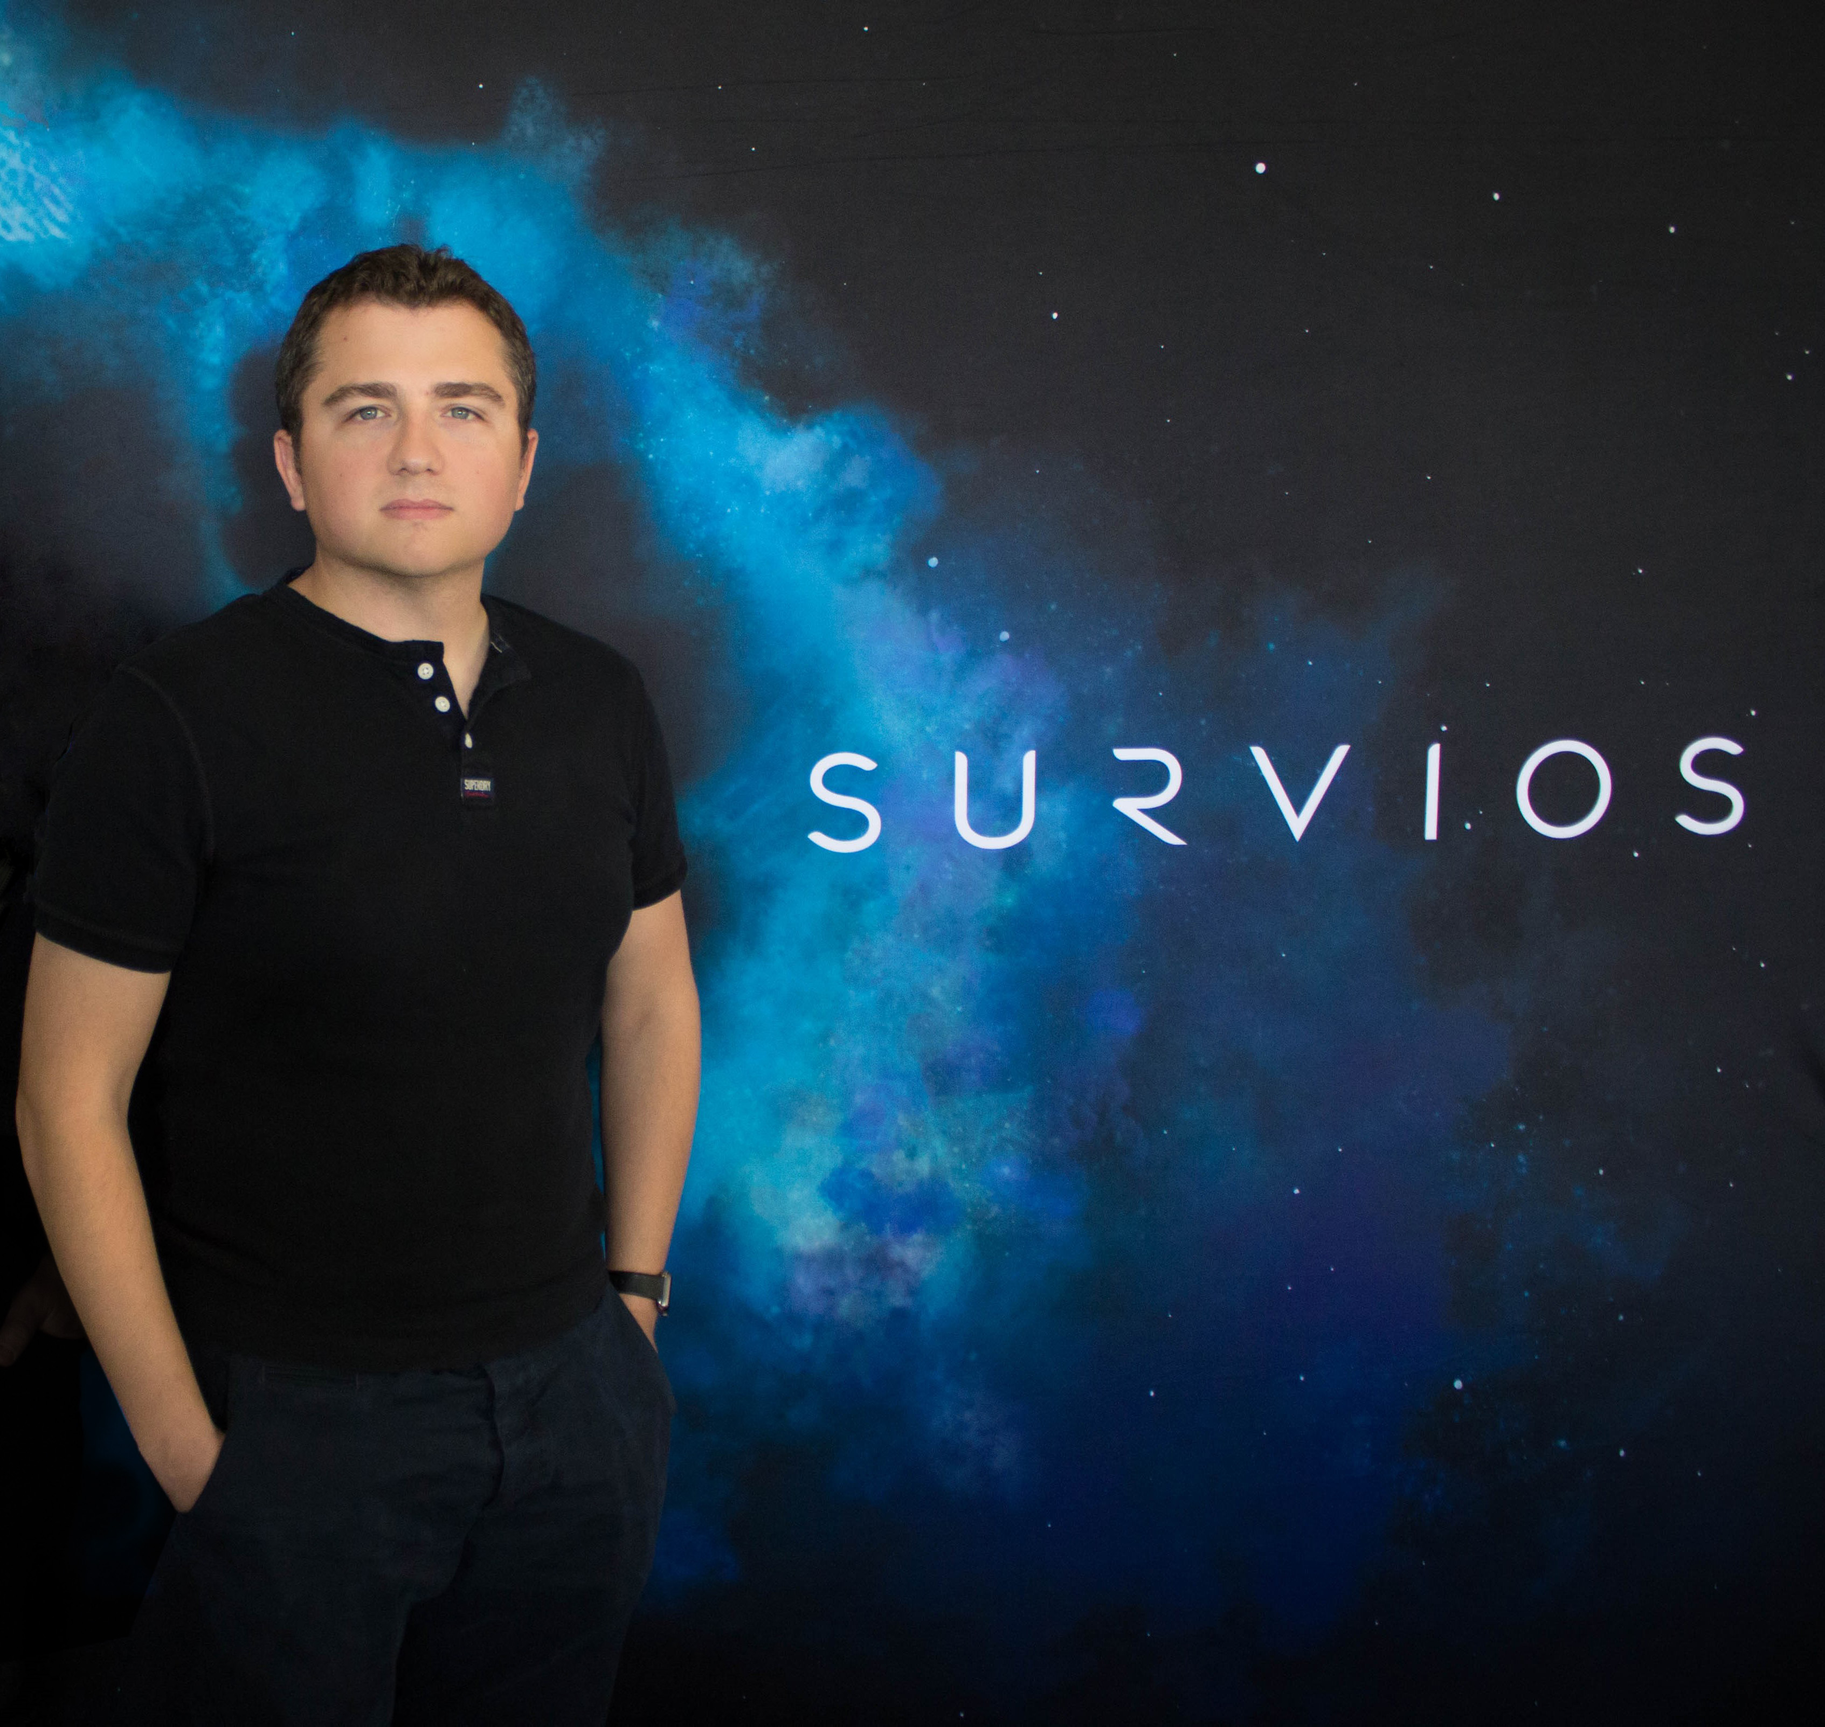 | Find out why you should pick up Electronauts!  ────  What are Nathan Burba’s Tips?  ────  Does @Martin76 get his question answered about adding your own tracks?  ────  Does @Chapuliicat find out about mulitplayer!  ────  Find out, even more, when you go to theplaystationbrahs.com

